Lab Exercise 6: Displaying Data from Multiple Tables

1. By using natural join, display the department’s name and their city.

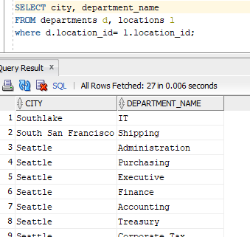

1. For each of this question, use USING and ON clause.
   1. Find the department name and city name for location 1700.

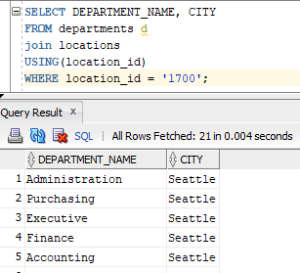

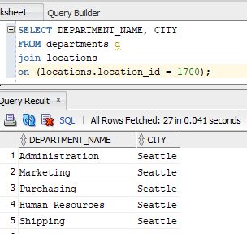

* 1. Find the job title and employees name that have that position.

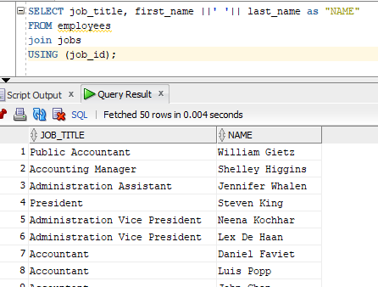

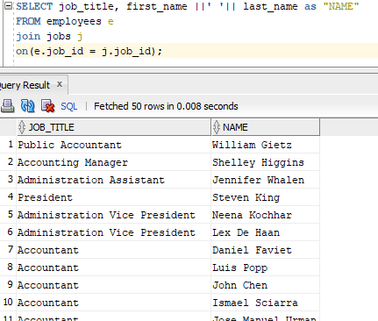

* 1. Find employees’ name that have salary less than 7000 and display together their job title.

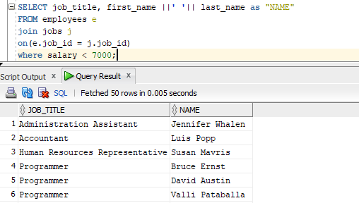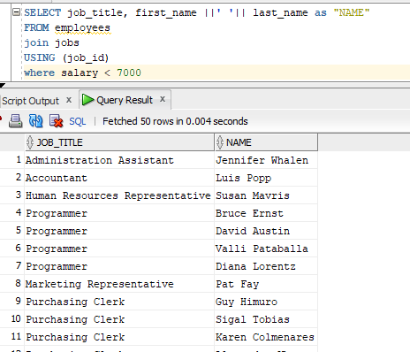

1. Find the employees’ last name and their hire date if they were hired before Hunold.

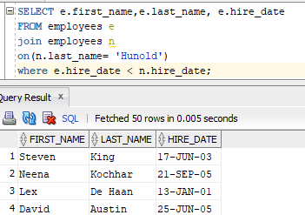

1. Find the manager’s name and their subordinate name.

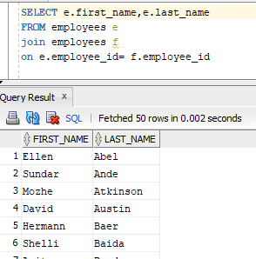

1. Find the employees name, eventhough they do not have any department. Display together the department’s name if they have it.

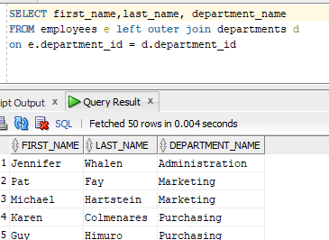

1. Find the department’s name and employees name eventhough no employee is in that deparment.

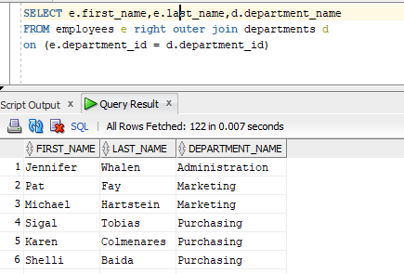

1. Cross join employee and job.

